Software Requirements Specification

for

Discworld: Ankh Morpork

Version 1.0 approved

Prepared by

Varun Pattiah, Taiseem Ahmed, Sumit Sarkar, Khurram Shehzad

Concordia University

Feb. 15, 2015

Table of Contents

Table of Contents i

Revision History ii

1. Introduction 1

1.1 Purpose 1

1.2 Document Conventions 1

1.3 Intended Audience and Reading Suggestions 1

1.4 Product Scope 1

1.5 References 1

2. Overall Description 2

2.1 Product Perspective 2

2.2 Product Functions 2

2.3 User Classes and Characteristics 2

2.4 Operating Environment 2

2.5 Design and Implementation Constraints 2

2.6 User Documentation 2

2.7 Assumptions and Dependencies 3

3. External Interface Requirements 3

3.1 User Interfaces 3

3.2 Hardware Interfaces 3

3.3 Software Interfaces 3

3.4 Communications Interfaces 3

4. System Features 4

4.1 System Feature 1 4

4.2 System Feature 2 (and so on) 4

5. Other Nonfunctional Requirements 4

5.1 Performance Requirements 4

5.2 Safety Requirements 5

5.3 Security Requirements 5

5.4 Software Quality Attributes 5

5.5 Business Rules 5

6. Other Requirements 5

Appendix A: Glossary 5

Appendix B: Analysis Models 5

Appendix C: To Be Determined List 6

Revision History

|  |  |  |  |
| --- | --- | --- | --- |
| **Name** | **Date** | **Reason For Changes** | **Version** |
|  |  |  |  |
|  |  |  |  |

# Introduction

## Purpose

The purpose of this SRS document is to give detailed description of the functionalities of Discworld Ankh-Morpork build1, which is board game. This document will give an insight into intended features, glimpse of user interface, software and hardware dependencies.

## Document Conventions

This document has some terminologies which a user might not be familiar with. See Appendix for these terms.

## Intended Audience and Reading Suggestions

This document is intended for the developers of the project Discworld Ankh-Morpork. The readers can focus on section 1 and 2 for taking brief overview of project.

## Product Scope

The project Discworld is software version of board game which is a multiplayer game intended for entertainment.

## References

***Actual Game Design***

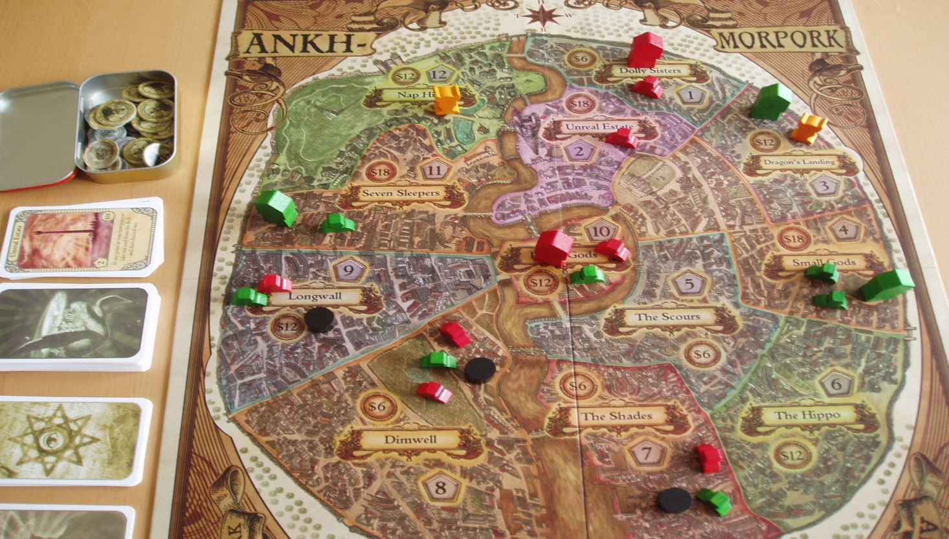

URL: https://talesfromthebookcave.files.wordpress.com/2014/08/ankh-morpork-board-photo.jpg

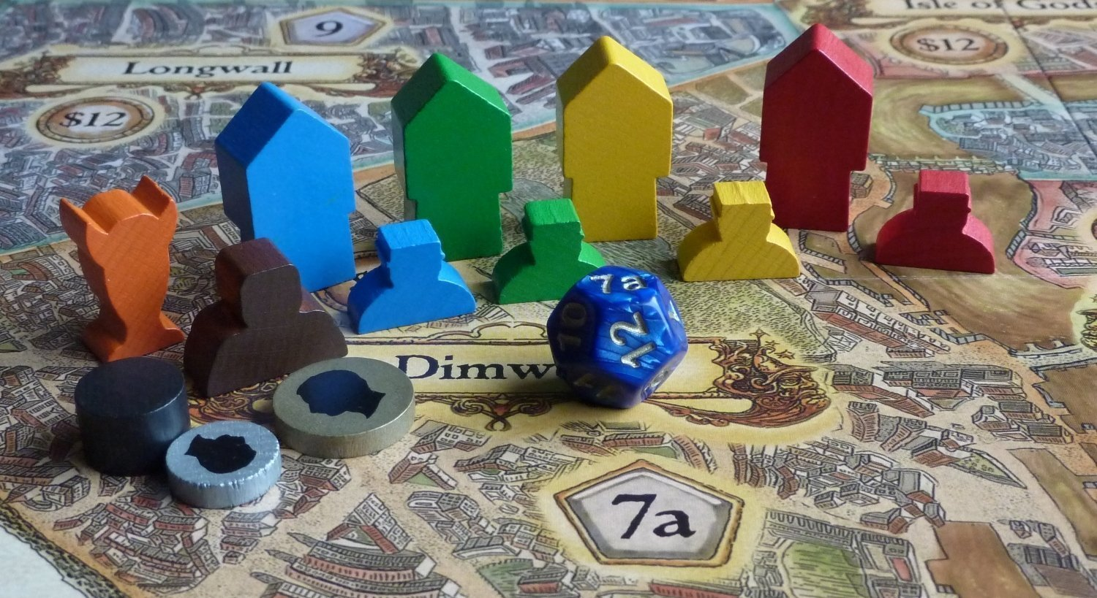**Minions, Buildings, Troll and Trouble Makers**URL: http://bonhomiegames.uk/WebRoot/Store10/Shops/3d7ba8af-1f8f-4927-ae85-334434e8a130/5427/EF84/15F7/2F9A/576D/0A48/3523/D792/Ankh_morpork2.jpg

**Some Cards**

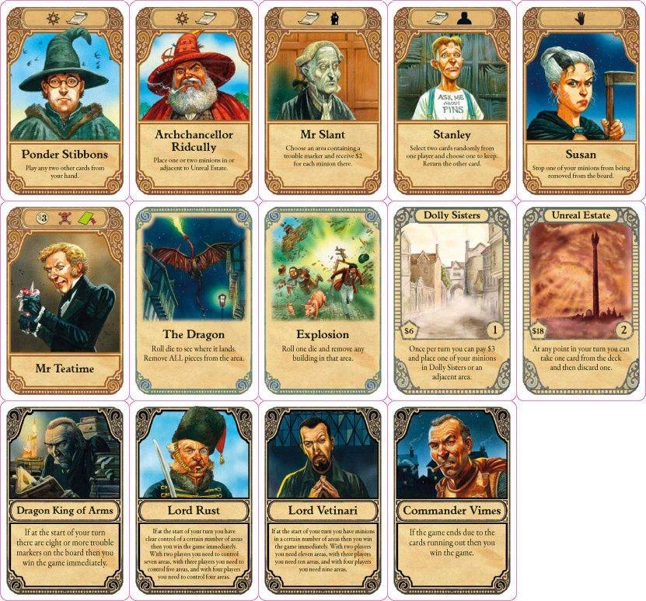

URL: http://www.svet-deskovych-her.cz/public/products/ai_big/Discworld_Ankh_Morpork-Karty3.jpg

# Overall Description

## Product Perspective

Discworld Ankh-Morpork is based on playing of cards, placing minions on different areas on board. Two to four players can play this at a who are given secret personality card which describes winning condition for that player. For build 1 we are not going much into details of the cards, characters, action associated with cards and random events.

## Product Functions

The various features and functionalities of the project are described below.

1. Viewing current status of game board
2. Minions with their colors in different areas of board
3. Buildings and trouble marker presence in each area
4. Demons and trolls existence
5. Status of players inventory
6. No. of minions left
7. No. of buildings currently established and areas cards holding
8. Money in dollars
9. Players cards which are green and brown
10. Loading previously saved games
11. Start new game

## User Classes and Characteristics

## 

## Operating Environment

The build 1 of the project does not feature real application of the game, hence it will available to be executed on eclipse using JDK.

## Design and Implementation Constraints

The first build does not allow multiple players to play from multiple machine i.e. all players are expected to play on a single system. Lack of time is measure concern in build 1, so we will be integrating real gaming in later versions.

## User Documentation

Here few links which can help to understand the game.

<https://www.youtube.com/watch?v=BHj-TMDw5kM>

<https://www.youtube.com/watch?v=AI5TTnQzIHg>

<https://www.youtube.com/watch?v=noaTLTTCCvs>

<https://www.youtube.com/watch?v=4kAiHSxlJ64>

<https://www.youtube.com/watch?v=MWMrtg5UoR4>

<http://www.treefroggames.com/wp-content/uploads/rules/am-rules-eng.pdf>

## Assumptions and Dependencies

Third party jar file “java-json.jar” has been used to parse game state stored in json format.

# Interface Requirements

## User Interfaces

At the moment the interface is console based where game will ask number of options such as start a new game, resume the existing game and after starting a game it will ask to save the current game status. Flow the game would be as follow

Enter Number of Players between 2 and 4

New Game

Enter the name of players

Each players is randomly assigned a color and a personality which is secret

At the start of the game, inventory of a player look like this

|  |  |  |  |  |  |  |
| --- | --- | --- | --- | --- | --- | --- |
| **Player 1 Current Inventory** | | | **Personality Card(Not displayed to other players)** | | | |
| Minions | Buildings | City Area Cards | | Money($) | Player Cards (Secret) | |
| 12 | 0 |  | | 12 | Green | Brown |
| 2, 23,4,16,7 |  |

After placing minions in different areas of the board. Game board status update

|  |  |  |  |  |  |
| --- | --- | --- | --- | --- | --- |
| **Current Status of Board (Name of the game)** | | | | | |
| City Areas(ID) | Minions | Trouble Marker? | Building? | Trolls | Demons |
| The Shades(1) |  |  |  |  |  |
| Dolly Sisters(2) |  |  |  |  |  |
| The Scours(3) |  |  |  |  |  |
| Dimwell(4) |  |  |  |  |  |
| Nap Hill(5) |  |  |  |  |  |
| Longwall(6) |  |  |  |  |  |
| The Hippo(7) |  |  |  |  |  |
| Dragon’s Landing(8) |  |  |  |  |  |
| Isle of Gods(9) |  |  |  |  |  |
| Small Gods(10) |  |  |  |  |  |
| Seven Sleepers(11) |  |  |  |  |  |
| Unreal Estates(12) |  |  |  |  |  |

## Software Interfaces

This project is to be developed in Java (Java Development Kit) using Eclipse IDE(Integrated Development Environment).

## Communications Interfaces

The first build does not any have communication feature but we are expecting to include this in future versions where user will move forward with respect to the game rules.

# System Features

The build 1 is supposed to contain certain core features which include game launching, game loading and saving the current game for later use.

## Launching a New Game

4.1.1 Description and Priority

Launching a new game will yield to initialize the data structure of the game.

4.1.2 Stimulus/Response Sequences

1. User is prompted to select number of players participating.
2. Players are asked to enter their names.
3. Each player is assigned a color randomly after which a secret personality card is given to them which they follow to win game. This build does not contains action associated with each card.
4. Every player is given a set of minions and buildings as per color to play, along with troll, demons, trouble marker on board.

## Loading Status of Game

4.1.1 Description and Priority

This feature will display the current status of a game, which will be used by a player to decide its moves.

4.1.2 Stimulus/Response Sequences

1. User will be asked to select the game for which status is to be loaded on screen.
2. A table will display the current status of the game board which describes which color minions are in which area, whether that area is having a building, troll, demons or trouble marker.
3. A separate table will display the status of inventory of all individuals.
4. The current player will be asked to make a valid move.
5. Updating inventory and status of game board on each move.

## Saving Current Status of Game*

4.1.1 Description and Priority

This feature will save the current status of a game into a file in JSON format for later use.

4.1.2 Stimulus/Response Sequences

When game would be saved it will ask to type a game name.

# Other Nonfunctional Requirements

## System Requirements

The game needs java SDK 6 on the system to run. If your system does not meet the minimum requirements for a game or your system meets the minimum requirements but not the recommended configuration, you may need to upgrade the appropriate hardware.

## Software Quality Attributes

It is required to make sure the inputs are valid with respect to game rules. In-case of invalid inputs software should show the proper messages in-order to restart / restore the game.

## Business Rules

The game have quite few specific rules under that it’s played. So the players have to follow the rules. In start of the games each player have a personality card, 12 minions, 10 dollors and 5 play card on the. Minions are positioned on some specific places and then game is started. For more details about the game rules you may follow the reference links in 1.5 paragraph above.